Counting Datasets

1) GVTBench by Tencent (2023) - This task asks the model to predict the number of a certain object appeared in the image. The task is constructed based on MS-COCO and Visual Commonsense Reasoning (VCR) datasets.

The annotation are formatted as :
{
"image_id":
"text_in": # Question
"text_out": # Ground-Truth Answer
"n_obj_exist": # The total number of objects appeared in the image
}

Object Counting on COCO Dataset
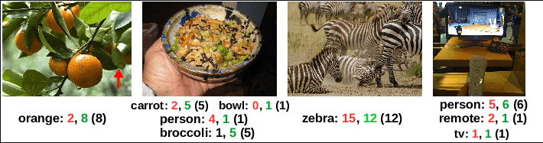

Results :

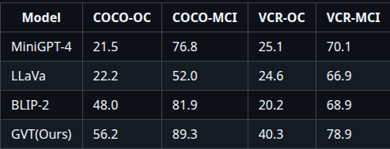

2) FSC – 147 (2021 approx) is an enhanced extension of the FSC-147 dataset developed for text-guided and open-world object counting tasks.
- It augments the original dataset by replacing simple and sometimes ambiguous class names with detailed natural language descriptions that precisely define the target objects to be counted.
- These richer textual descriptions enable models to perform object counting based solely on free-form language prompts, without relying on predefined category labels.
- FSC-147-D retains the original FSC-147 images and annotations, ensuring compatibility with existing benchmarks while improving semantic clarity.
- The dataset is particularly well-suited for evaluating language-conditioned and open-vocabulary counting models, especially in scenarios involving unseen or fine-grained object categories.
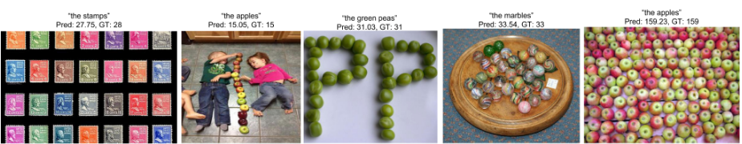
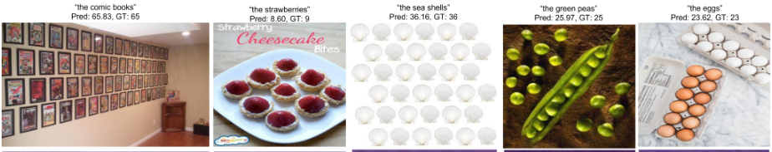
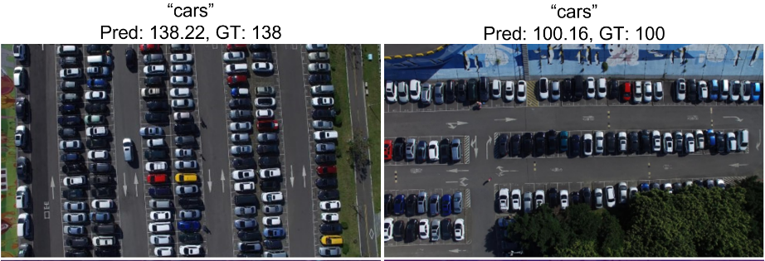

3) CountBench (Feb 2023) a new image-text counting benchmark for evaluating a model’s understanding of object counting
- It contains 540 image–caption pairs, with object counts ranging from two to ten.
- Captions explicitly state the number of objects visible in each image.
- The dataset is used only for testing and has no overlap with the training set.
- Images were selected using an automatic filtering pipeline, followed by manual verification to ensure count correctness.
- After balancing, the final dataset includes 60 samples per number category (“two” to “ten”).

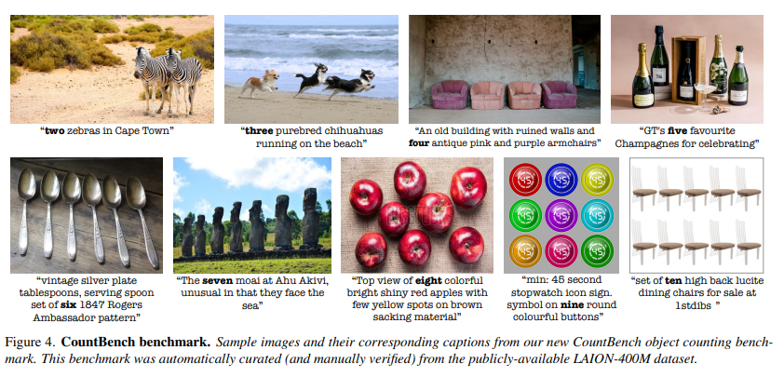

Results :
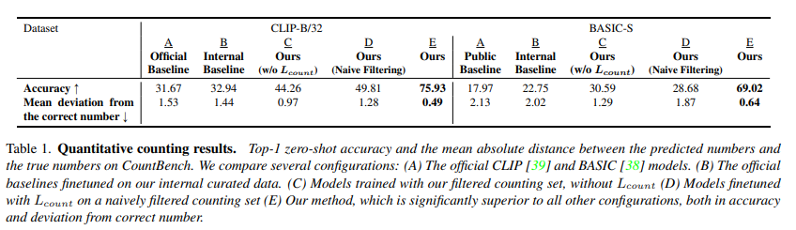
4) CountQA (Sep 2025): How Well Do MLLMs Count in the Wild : Multimodal Large Language Models (MLLMs) show strong visual understanding but struggle with object counting, a key cognitive skill.
- Existing benchmarks fail to adequately test counting in complex, real-world scenarios with dense and cluttered scenes.
- CountQA is introduced as a challenging new benchmark to address this gap.
- It contains 1,500+ question–answer pairs based on real-world images with high object density, occlusion, and clutter.
- Evaluation of 15 state-of-the-art MLLMs shows limited performance, with the best model achieving only 42.9% accuracy, degrading further as counts increase.
- CountQA aims to enable the development of numerically grounded and spatially aware MLLMs, with dataset and code to be open-sourced.

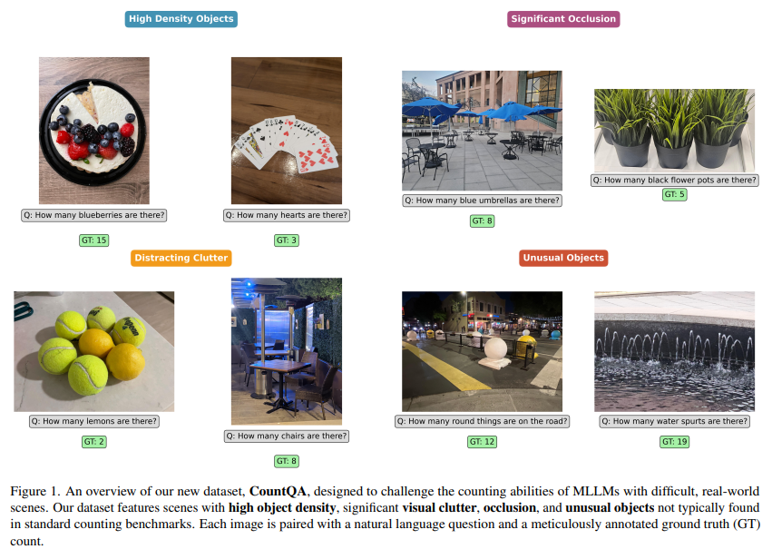

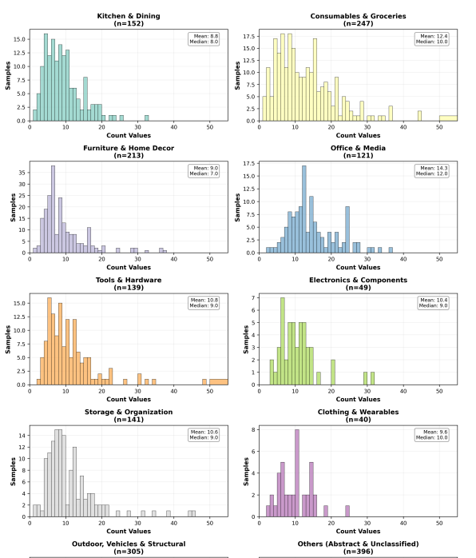
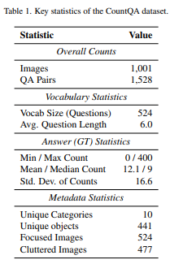

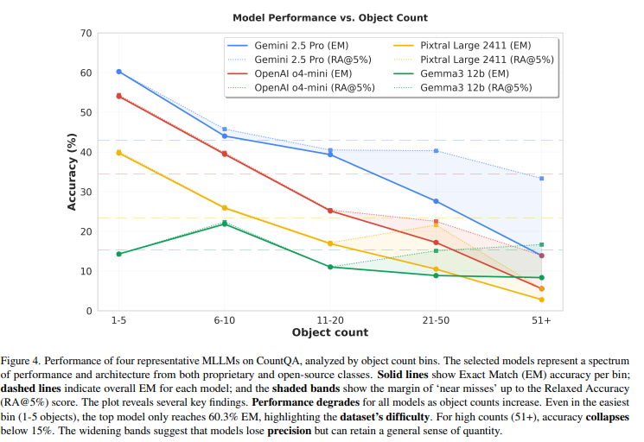
Results :

SEED-Bench (2024)
- What it is: SEED-Bench is a large-scale benchmark for evaluating Multimodal Large Language Models (MLLMs) via objective multiple-choice questions that test models’ comprehension of both spatial and temporal visual content.
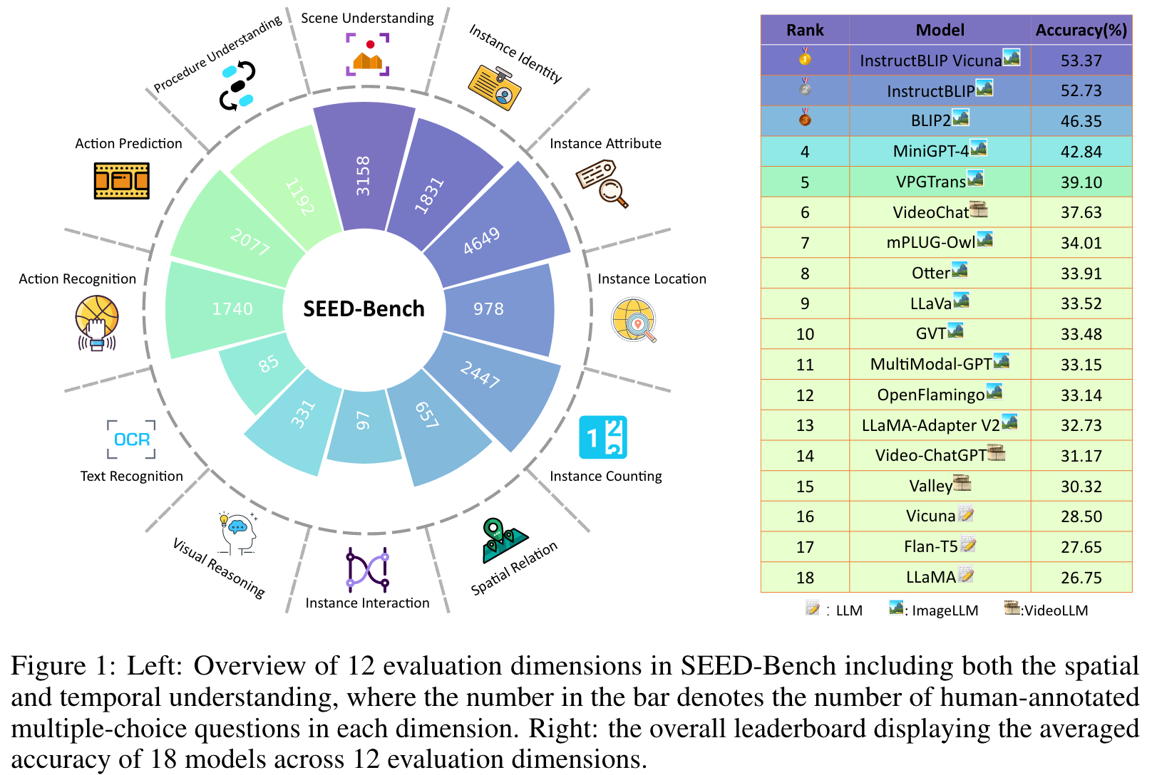

- Scale & Structure:
  - ~19,000 multiple-choice questions covering 12 evaluation dimensions across spatial and temporal understanding.
  - Later iterations (e.g., SEED-Bench-2) extended this to see hierarchical capabilities up to text and image generation with ~24,000 questions across 27 evaluation dimensions.

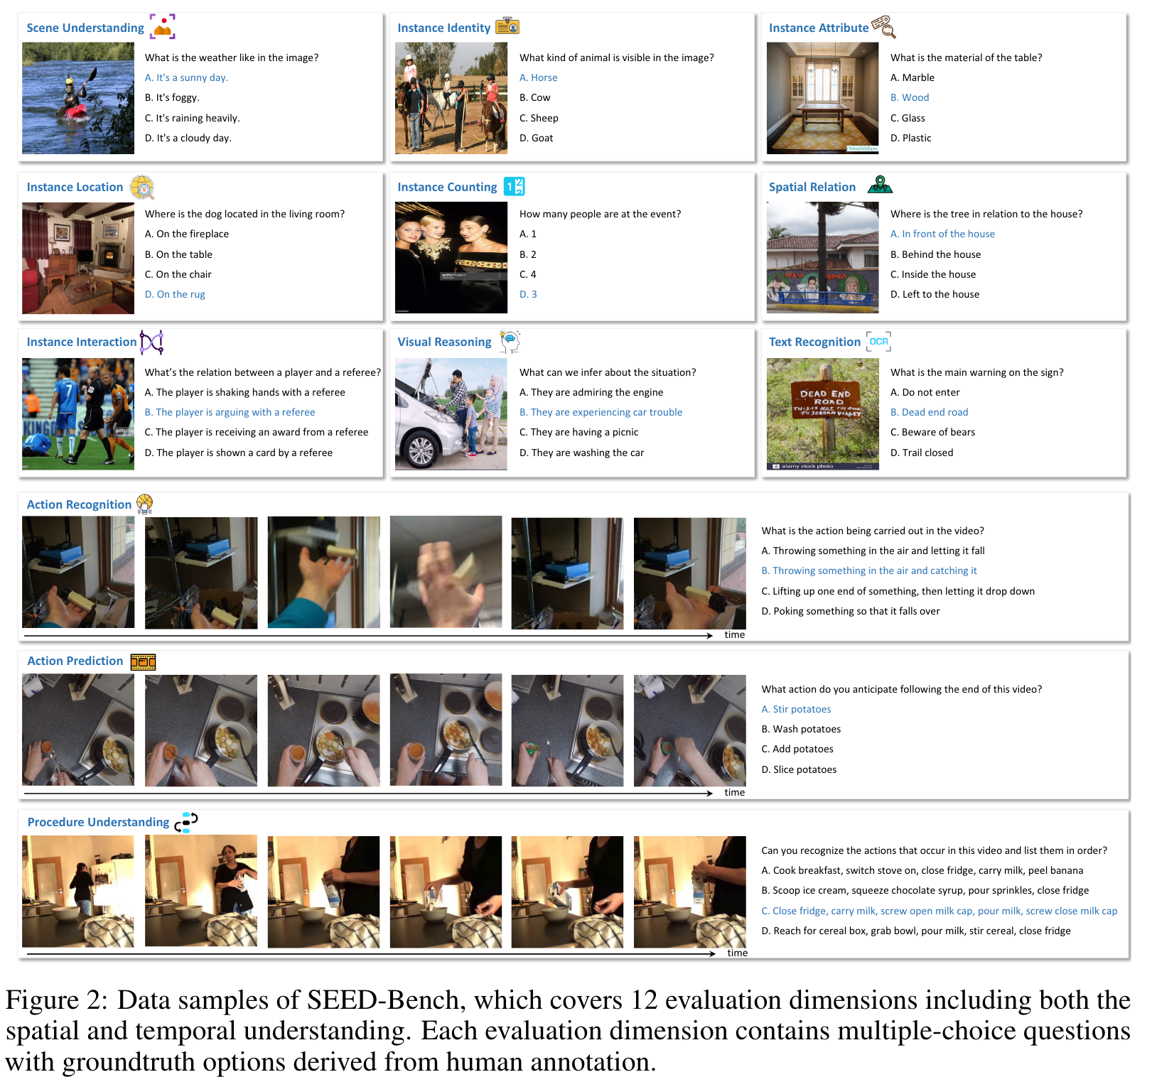

- Main Evaluation Focus:
  - Spatial understanding: scene comprehension, instance identity/attributes/location, counting, spatial relations, visual reasoning, text recognition.
  - Temporal understanding: action recognition, action prediction, procedural sequencing from video frames.
- How It Works: Each task is formatted as a multiple-choice question (A/B/C/D) where the correct answer is human-annotated, allowing response accuracy measurement without subjective open-ended scoring.
- Data Sources:
  - Images: Conceptual Captions dataset.
  - Videos: Something-Something v2, Epic-Kitchen 100, and Breakfast Actions dataset for temporal tasks

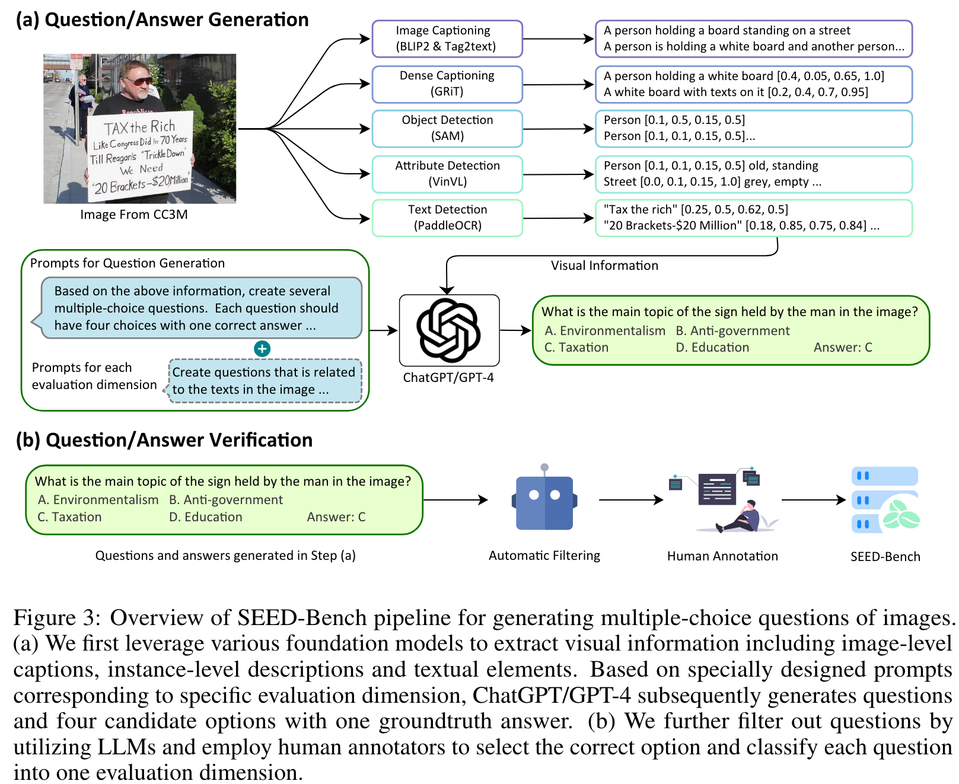
Dataset creation method:

